
Foundations of Programming
Assignment No. : 01
Name: Arnav Nair
PRN: 1262253761
Div 1
1. PROBLEM STATEMENT:
Write a program in C to check whether a given year is a Leap Year OBJECTIVE:
1. To understand the use of conditional statements in C programming. 2. To implement logical conditions for solving real-world problems.
3. To develop problem-solving skills using decision control structures.
THEORY:
2. Theory for a Leap Year - year that contains 366 days instead of the usual 365 days.
Rules:
• A year is a leap year if it is divisible by 400, OR
• A year is a leap year if it is divisible by 4 but not divisible by 100.

3. Algorithm:
Step 1: Start
Step 2: Declare an integer variable year.
Step 3: Display the message "Enter the year:".
Step 4: Read the value of the year.
Step 5: If the year is divisible by 400, → Print "It is a leap year". Else if the year is divisible by 4 and is not divisible by 100, → Print "It is a leap year" .Else, → Print "It is not a leap year".
Step 6: Stop
PLATFORM: Linux

Program:
#include <stdio.h>
int main() {
int year;
printf("Enter the year: ");
scanf("%d",&year);

if (year%400==0){
// printf("It is a leap year");
printf("It is a leap year");
}
else if(year%4==0){
if (year%100!=0){
printf("It is a leap year");
}
else{
printf("It is not a leap year");
}
}
return 0;
}

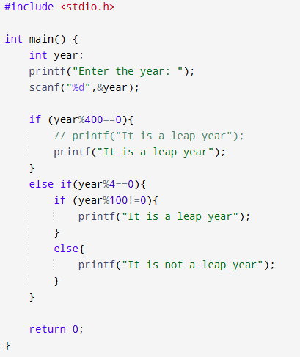
Sample Input
2024
Sample Output
2024 is a Leap Year
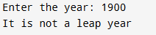
CONCLUSION: Thus, the program successfully checks whether a given year is a Leap Year using conditional statements in C.

FAQs:
1. What is a leap year?
2. Why is the year 1900 not a leap year but 2000 is? 3. Which operators are used in this program? 4. Difference between if and if–else statements.

